NGINX INSTALLATION

* yum install -y epel-release
* yum -y install nginx
* systemctl start nginx

Nginx ka status check kerne k liay

* systemctl status nginx

Nginx stop kerne k liay

* systemctl stop nginx
* Agr nginx chal nahi raha hay or

Yay command run kerne pay “**systemctl status nginx**”

Active: **failed** ya Active: **inactive (dead)** aai

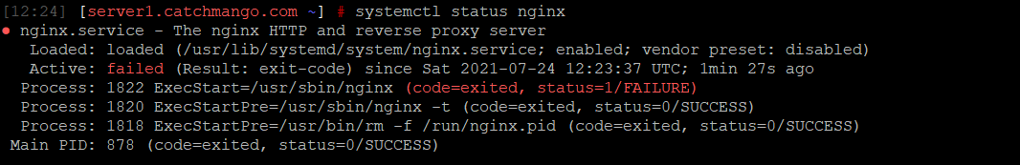

To phir yay commands use kerni hain:

* sudo fuser -k 80/tcp
* sudo fuser -k 443/tcp

Then execute

* sudo service nginx restart

Nginx **Active** hojai ga

Delete complete folder

sudo rm -rf folderName

move files and folders of any folder

sudo cp -r build/* /var/www/html

rename file name

mv oldfile.txt newfile.txt

sudo ln -s /etc/nginx/sites-available/ nftgurus /etc/nginx/sites-enabled